## 1. Steps to process

* BTs are most commonly found in the *Payment Schedule* section toward the end of the contract. Each line item would be its own BT.

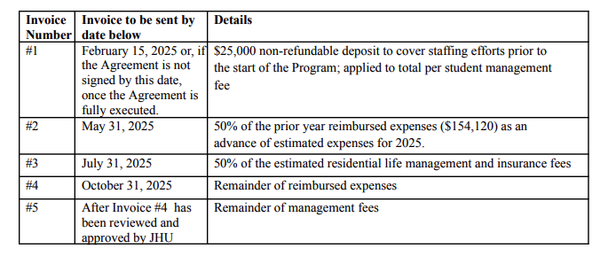

* Payment Schedule typically includes all committed payments, including estimated amounts based on prior year data.
  + These will all be BTs, even if we can’t calculate the total with the information given
    - In these cases, the BT will be $0.
* Billing Start Date: use the date listed in the Payment Schedule for each line item.
  + Example: "Deposit Payment due February 15, 2025" → Billing Start Date = February 15, 2025
* Service Start Date: Same as Billing Start Date for each line item
* Months of Service: Default to 0 months
* Total Price: use the total amount listed per payment in the Payment Schedule.
  + Include estimated fees per the calculation if possible
    - Example: “50% of the prior year reimbursed expenses ($154,120)”
      * Will be .5 * $154,120 = $77,060
  + If the amount is to-be-determined or variable based on actual expenses that haven’t occurred yet (Example: “Remainder of reimbursed expenses”) or the estimate isn’t listed, create a BT with $0.
* Frequency: set to None — Summer Discovery bills based on milestones, not recurring intervals, so there wouldn’t be a frequency.
* Net Terms: Use 15.
* Quantity: Default to 1.
* Usage/Overage Items: **Ignore**
  + Only need to follow the payment schedule, which should be flat fees only
  + There will be many BTs throughout the document, but we only want to focus on the given payment schedule.
  + Example to ignore: "Additional meals may be purchased at $25 per meal"
* [Integration Item Mapping](https://docs.google.com/spreadsheets/d/1xStVtsVeCTnAP-xR_vFhkx0K_X3x-zvEboPBI3apllE/edit?gid=0#gid=0)

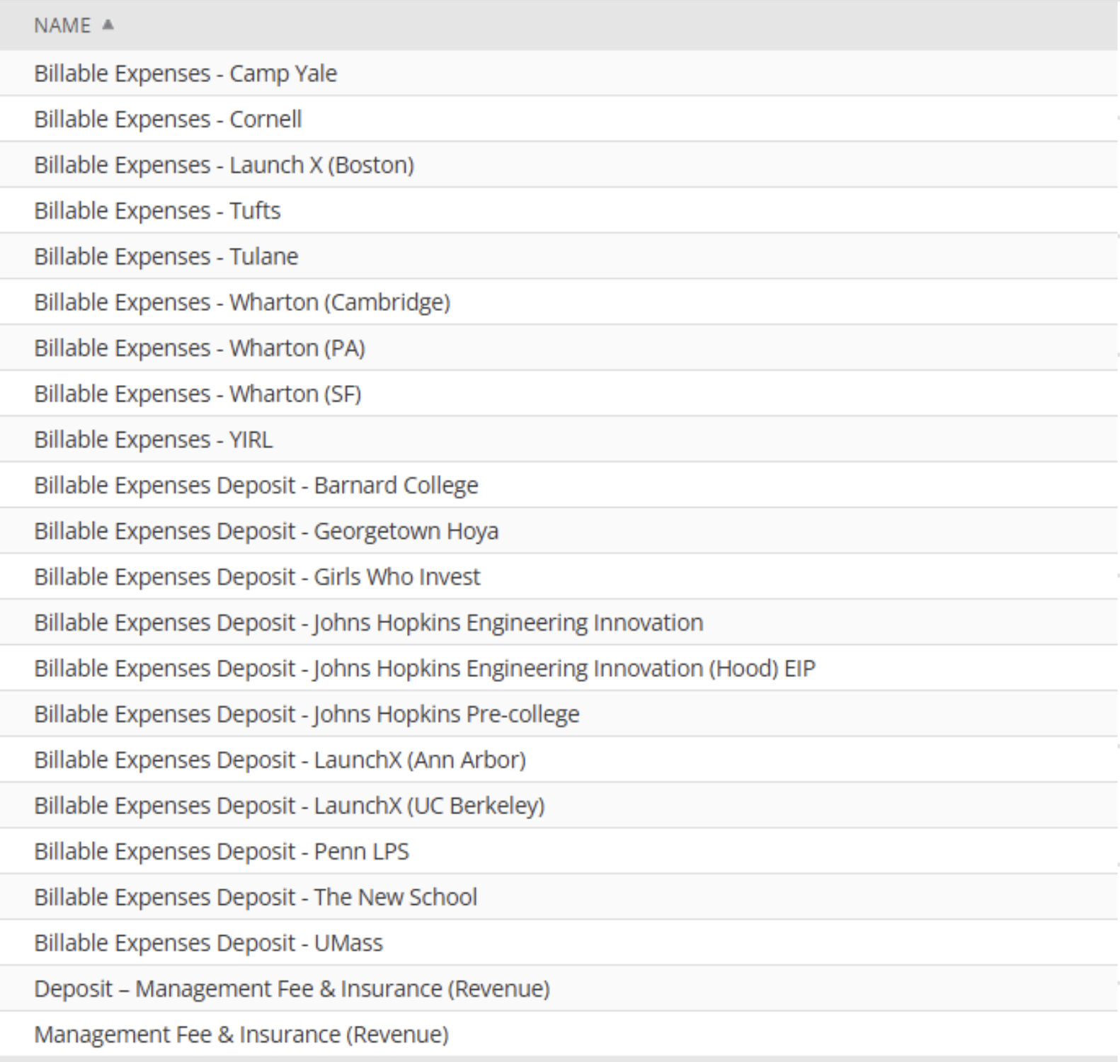

* 3 types
  + Billable Expenses
    - For any expenses, use the billable expenses integration item with the customers name at the end
    - Will use this for pretty much everything that doesn’t specifically say “fee” or “deposit” which would use the 2 below
    - If doesn’t fit the below 2 and doesn’t seem like it should be a billable expense, please flag
    - There is no difference between “Billable Expenses Deposit” and “Billable Expenses.” Please just be sure to match the customer name.
  + Management Fee & Insurance
    - Anything that is a “fee”
  + Deposit - Management Fee & Insurance (Revenue)
    - “Anything that is a “deposit”